# The data analysis process and this program:->

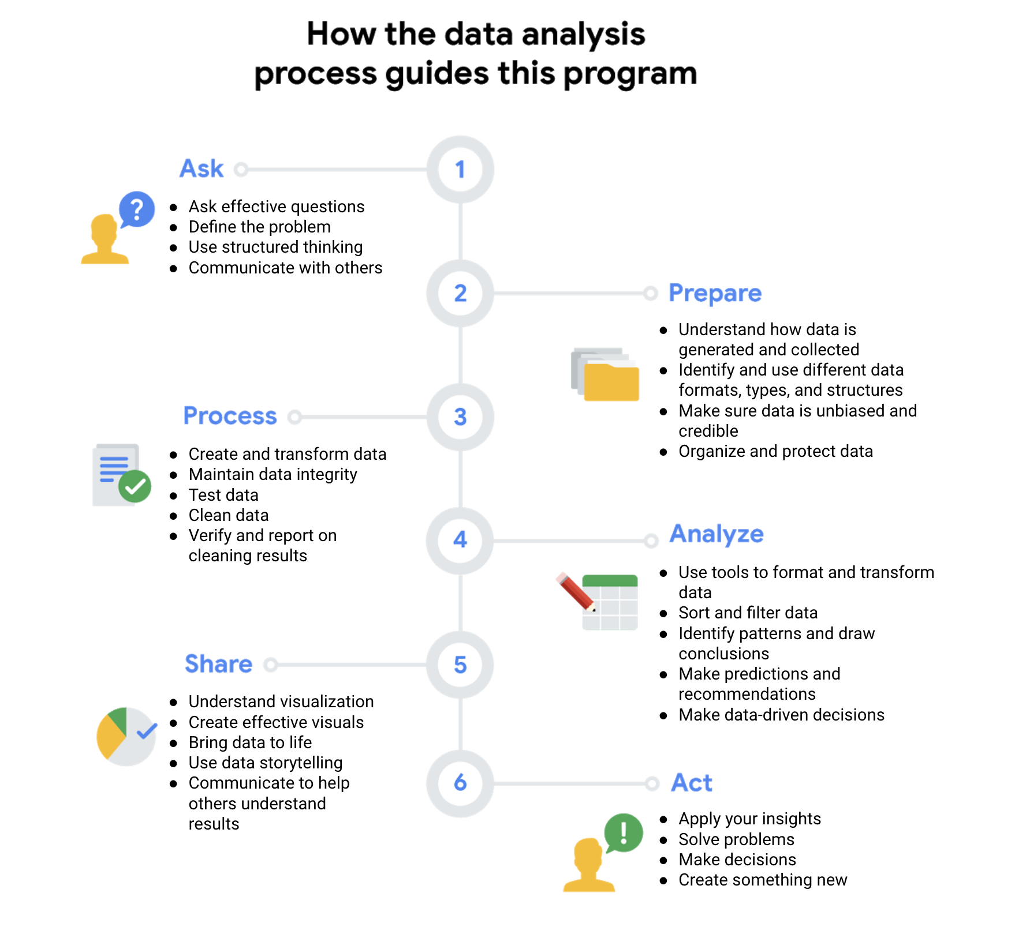**Summary:**

**Data Analyst Tools:**

1. **Spreadsheet: A digital worksheet which stores and organizes data.**

*This is important because the usefulness of data depends upon how well its structured*

*One of the most import feature of spreadsheet is formulas/functions, it is a set of instructions that perform a specific calculation using the data in a spreadsheet*

*Ex. sum, avg, count, etc*

1. **Query Language: A computer programming language that allows you to retrieve and manipulate data from a database**

*We’ll be learning SQL, its easy to understand and works very well with all kinds of databases.*

*Query means questions, we can also think of it as a request made to the database.*

*We can do a lot of different things such as create, insert, update, delete, etc*

1. **Data Visualization : Graphical representation of information, some examples include graphs, maps and charts.**

**After the data has been processed and analyzed the insights are visualized so it can be understood and shared.**

**This makes it easy for stakeholders to draw conclusions, make decisions and come up with strategies.**

**Some popular tools are Tableau and looker, DA likes using Tableau because it helps them create visuals that are very easy to understand.**

**Learning Log: Organize your data in a table**

| **Date:** 21/12/2022 | **Course/topic:** Course 1: Foundations: Data, Data Everywhere | | |
| --- | --- | --- | --- |
| **Learning Log:** Organize your data in a table | | |
| **Now it’s your turn!** | Now, you can create a table for your data. You can use Google Docs, Microsoft Word, or draw a table with pen and paper. To create your table, follow the instructions for your preferred method:  **How to create a table in Google Docs**  To create a table in a Google Doc, navigate to the toolbar at the top of the document. Click Insert > Table and move the cursor over the grid until you highlight the number of columns and rows you want. For step by step directions visit: [Add and edit tables](https://support.google.com/docs/answer/1696711)  **How to create a table in Microsoft Word**  To create a basic table in Microsoft Word, navigate to the toolbar at the top of the document. Click Insert > Table and move the cursor over the grid until you highlight the number of columns and rows you want. For step by step directions visit: [Microsoft Word Insert a Table](https://support.microsoft.com/en-us/office/video-insert-a-table-9bc4b562-4f88-4ba0-9a59-4b29cfa0bb29)  **A third option: pen and paper!**  If you want to create your learning log using pen and paper, that’s just fine! You can draw your table manually, and fill in the data. You can consider adding extra empty rows for future data, if you decide to continue recording data.  After you create your table you can move on to the reflection.  This is the previously gathered data:->  Watching anime:   * December 4 Watched World Trigger Season 1 7 episodes * December 5 Watched World Trigger Season 1 12 episodes * December 6 Watched World Trigger Season 1 4 episodes * December 7 Watched World Trigger Season 1 3 episodes * December 8 Watched World Trigger Season 1 4 episodes * December 9 Watched World Trigger Season 1 22 episodes * December 10 Watched World Trigger Season 1 20 episodes   Season 1 finish   * December 11 Watched World Trigger Season 2 10 episodes * December 12 Watched World Trigger Season 2 2 episodes and Season 3 14 episodes   Season 2 and 3 finish   * December 13 Watched Noragami OVA * December 14 No anime * December 15 No anime * December 16 Mob psycho Season 3 3 episodes * December 17 No anime  | Date | Anime | Season | Episodes | Status | | --- | --- | --- | --- | --- | | 04/12/2022 | World Trigger | 1 | 7 | Start | | 05/12/2022 | World Trigger | 1 | 12 | - | | 06/12/2022 | World Trigger | 1 | 4 | - | | 07/12/2022 | World Trigger | 1 | 3 | - | | 08/12/2022 | World Trigger | 1 | 4 | - | | 09/12/2022 | World Trigger | 1 | 22 | - | | 10/12/2022 | World Trigger | 1 | 20 | Finish | | 11/12/2022 | World Trigger | 2 | 10 | Start | | 12/12/2022 | World Trigger | 2,3 | 16 | S2Finish  S3  Start&Finish | | 13/12/2022 | Noragami | OVA | 2 | Start&Finish | | 14/12/2022 | None | None | None | None | | 15/12/2022 | None | None | None | None | | 16/12/2022 | Mob Psycho 100 | 3 | 3 | - | | | |
| **Reflection:** | I’m currently a full time student so most of my activities are related to learning and I’d like to arrange them in tabular format. For example a table consisting of columns such as time, website/place, activity, duration etc and entries would be my daily tasks such as solving a codechef problem, learning from the Google Data Analytics course, learning excel, practicing SQL, making a tweet, uploading learnt material on github, etc  I can also plan out important dates in a tabular format for better representation or as a sort of checklist. | | |
| **Question and response:** | Reflect on, and address, the opportunities in your personal life or current job to organize data into tables. | | |